Lab 7: Find a procedure to transfer the files from one virtual machine to another virtual machine

Objective
Find a procedure to transfer files from one virtual machine to another.
Tools Required
Tool | Purpose | Installation
VirtualBox | Hypervisor to create virtual machines | https://www.virtualbox.org/wiki/Downloads
Vagrant | Automates VM creation/configuration | https://developer.hashicorp.com/vagrant/downloads
What is Vagrant?
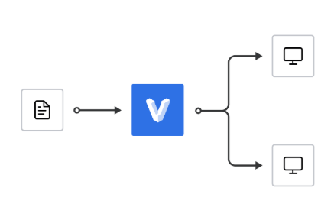
Vagrant is the command line utility for managing the lifecycle of virtual machines. Isolate dependencies and their configuration within a single disposable and consistent environment.

Part 1 — Creating a Local Virtual Network in VirtualBox

Step 1: Open VirtualBox
- Launch the Oracle VM VirtualBox Manager.
- Ensure no VMs are running initially.
Step 2: Create an Internal Network using Command Line
Open Command Prompt (Windows)
Command | Meaning
cd C:\Program Files\Oracle\VirtualBox\ | Change Directory to C:\Program Files\Oracle\VirtualBox\
VBoxManage natnetwork add --netname testnet --network "192.168.56.0/24" --enable --dhcp on | - --netname testnet → Names your network “testnet”.  - --network "192.168.56.0/24" → Creates a network range (subnet mask 255.255.255.0).  - --enable → Activates the NAT network.  - --dhcp on → Automatically assigns IPs to connected VMs.

Screenshot for step 1 and step 2
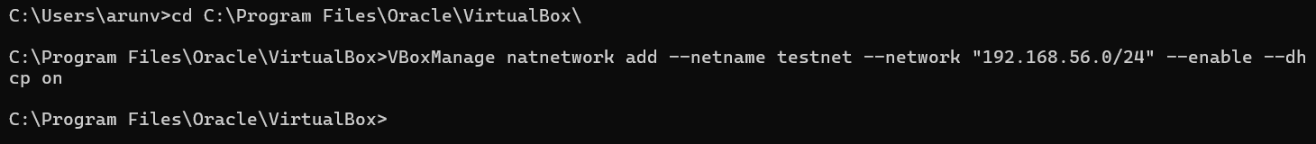
Step 3: Verify the Network
Command | Meaning
VBoxManage list natnetworks | Change Directory to C:\Program Files\Oracle\VirtualBox\
VBoxManage list natnetworks
You should see something like:
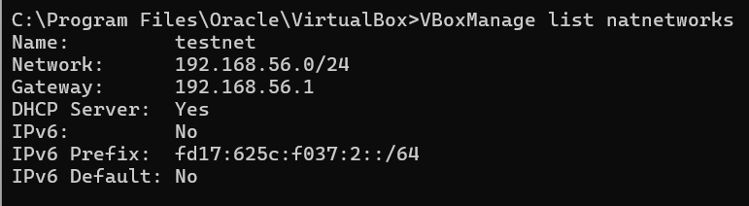
Part 2 — Creating Virtual Machines and Attaching to the Network
We’ll use Vagrant to simplify VM setup.
Step 4: Create a Project Folder
Command | Meaning
cd C:\Users\arunv | Change Directory to create a project folder
mkdir IaaS_Lab1 | create a project folder
cd IaaS_Lab1 | Change directory

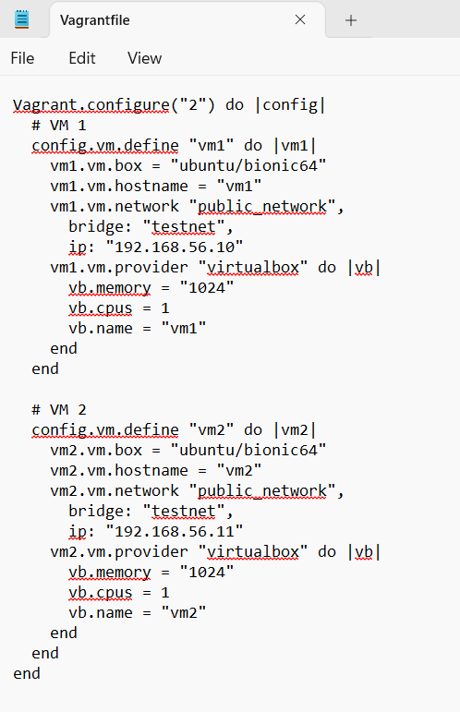
Figure 1 creating a Vagrant file
Explanation:
- Two VMs (vm1 and vm2) are created using Ubuntu images.
- Both are connected to the same testnet network.
Step 6: Launch the Virtual Machines
Run the following commands:
Command | Meaning
vagrant init | This will create a new environment  and will create a new file name “Vagrantfile”
Vagrant.configure("2") do |config|  # VM 1  config.vm.define "vm1" do |vm1|  vm1.vm.box = "ubuntu/bionic64"  vm1.vm.hostname = "vm1"  vm1.vm.network "public_network",  bridge: "testnet",  ip: "192.168.56.10"  vm1.vm.provider "virtualbox" do |vb|  vb.memory = "1024"  vb.cpus = 1  vb.name = "vm1"  end  end  # VM 2  config.vm.define "vm2" do |vm2|  vm2.vm.box = "ubuntu/bionic64"  vm2.vm.hostname = "vm2"  vm2.vm.network "public_network",  bridge: "testnet",  ip: "192.168.56.11"  vm2.vm.provider "virtualbox" do |vb|  vb.memory = "1024"  vb.cpus = 1  vb.name = "vm2"  end  end  end | Open the Vagrantfile in notepad. Delete all the contents. Copy and paste the code in the Vagrantfile  as shown in figure 1
vagrant up | This will:  - Download the Ubuntu box (first time only)  - Create and start both VMs  - Attach them to the testnet network
vagrant ssh vm1  ip addr show  vagrant ssh vm2  ip addr show | In command prompt type this command and notedown the ip address of both vm1 and vm2

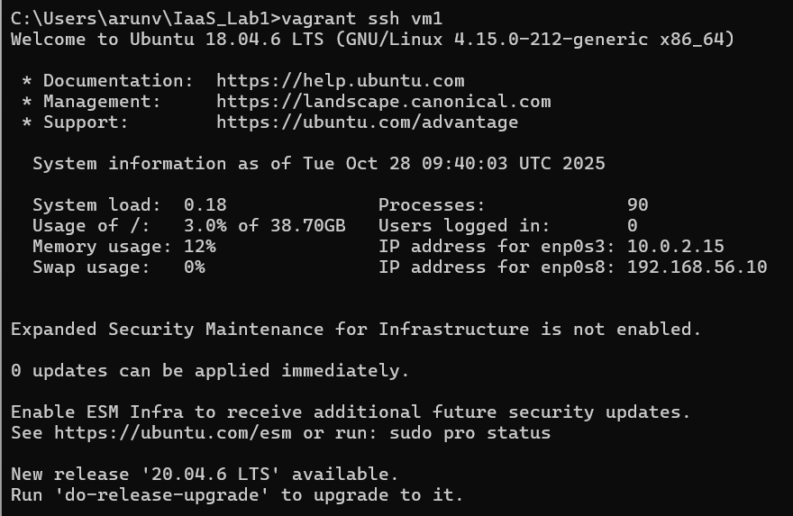

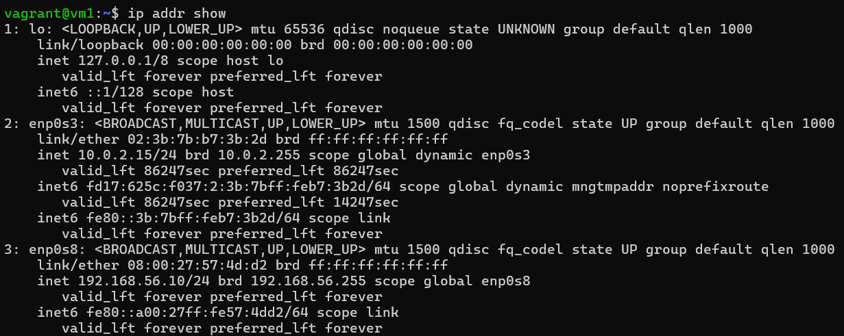

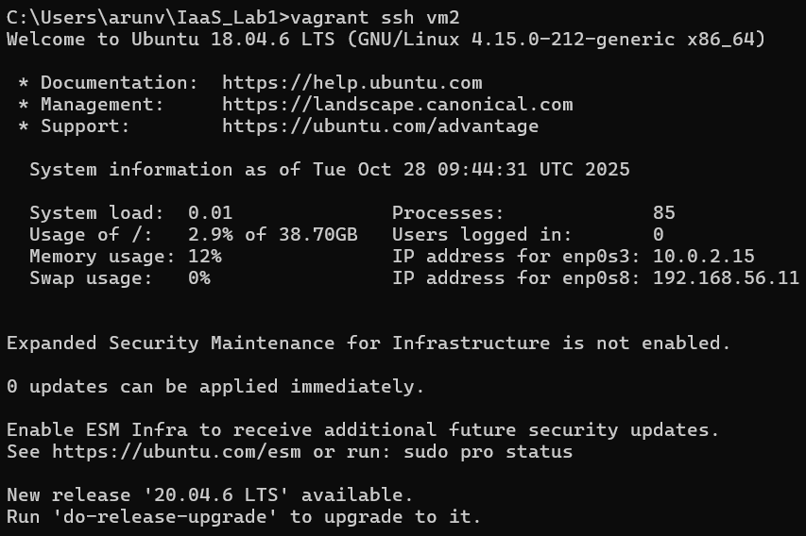
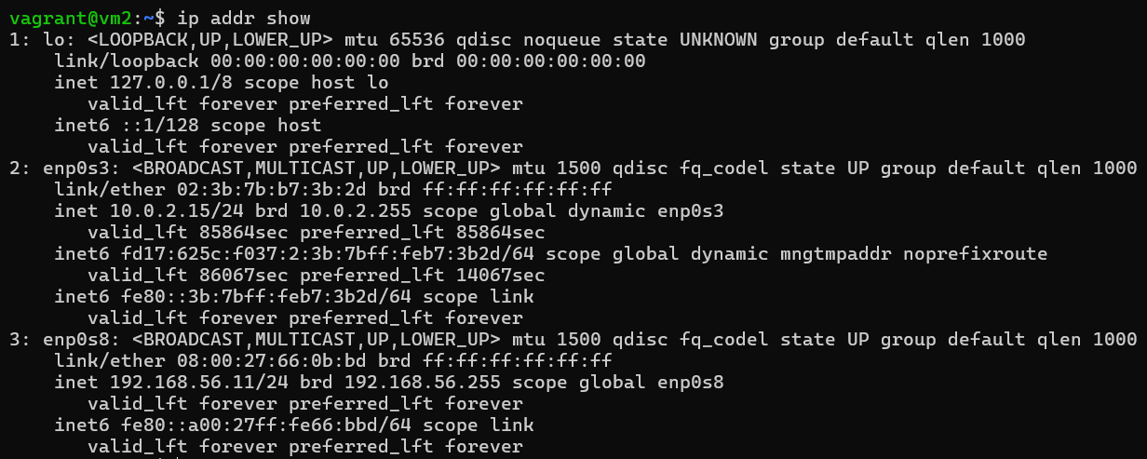
Part 3 — Testing Network Connectivity
Step 8: Ping Between VMs
From inside vm2:
Command | You should see responses:
ping 192.168.56.10 | 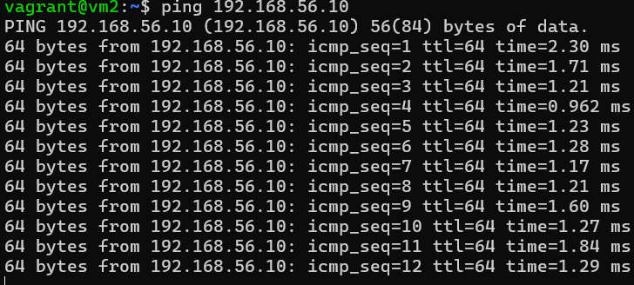
Expected Output:
Both VMs can communicate over the internal network — meaning the IaaS network setup is successful.

